Multivariable Regression Results
Wen-Han Hu(whu24)
Task .1 Basic Statistics Analysis
Variables histogram
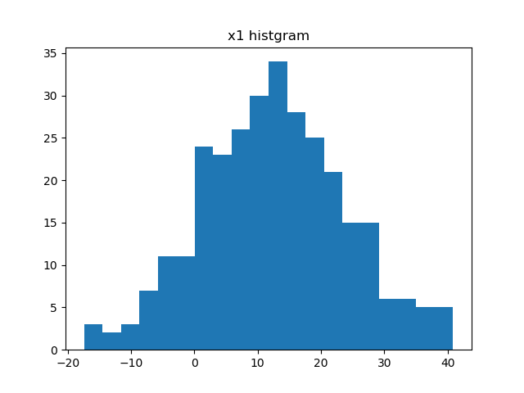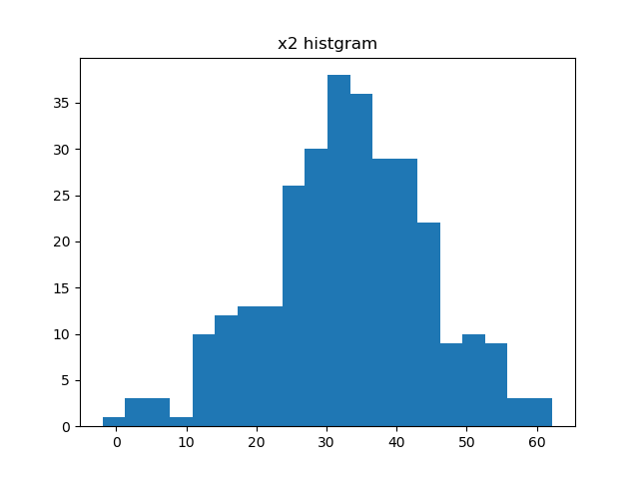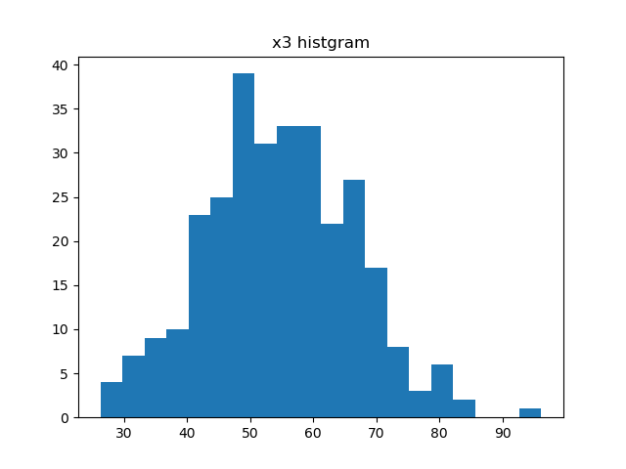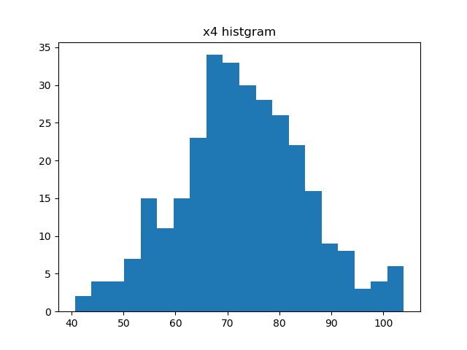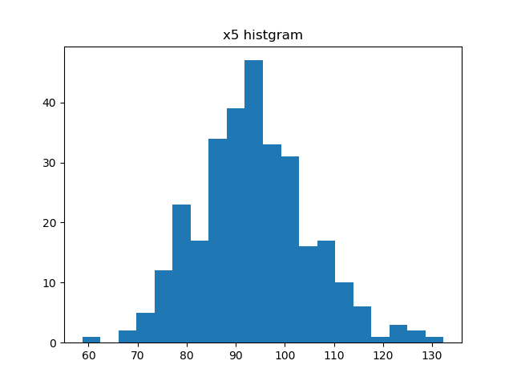
Variables mean and variance
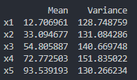
Correlation Matrix
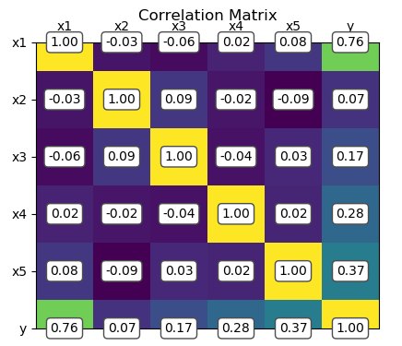
Comment
Based on the basic analysis above, we can know that all the variables are normal distributed with different mean and variance. The correlation matrix shows that all the variables are independent, and x1 has higher correlation with y comparing to other variables.

Task 2
Summary of simple linear regression
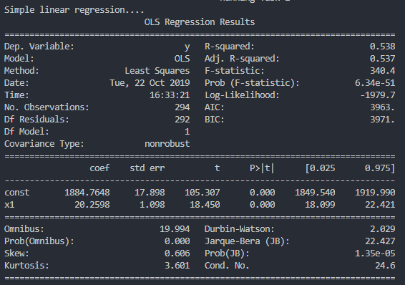
Plot of simple linear regression:
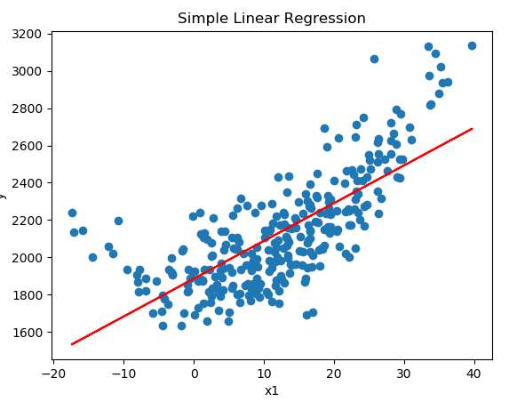
Residual analysis of simple linear regression
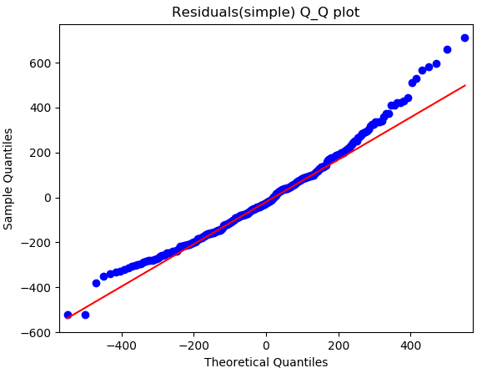
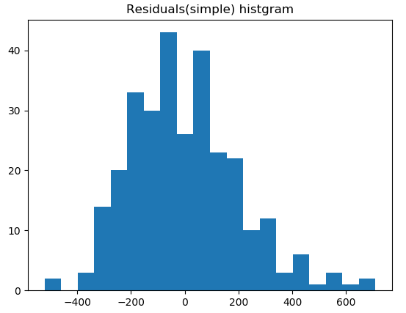

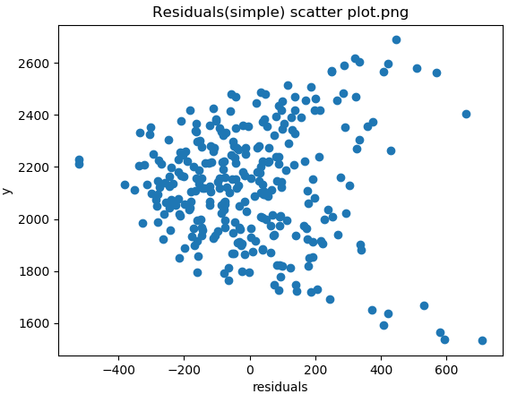
Comment
First, we remove the outliers if z-score of data in that independent variable is greater than 3. In other word, we only keep the data which is within 3 standard deviation. Next, based on the results of simple linear regression, we have the p-values of coefficients which is less the 95% confidence. Consequently, we reject the null hypothesis that the coefficients a₀ and a₁ are zero.
For residual analysis, both left tail and right tail of distribution of the residuals does not match that of the normal distribution. We cannot make sure the residuals if normal distributed. After we run the chi-square test, we reject the null hypothesis which is residuals are normal distributed. This makes some sense since the R-squared only 0.538. which is not very good fit. Finally, there is no discernible trend in the residuals scatter plot.

Summary of polynomial regression
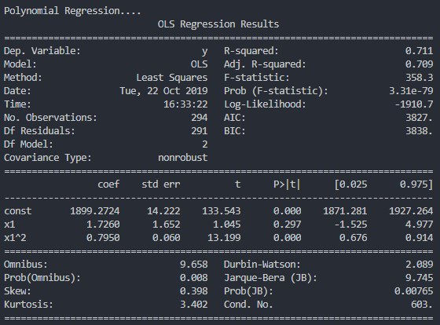
Plot of polynomial regression:
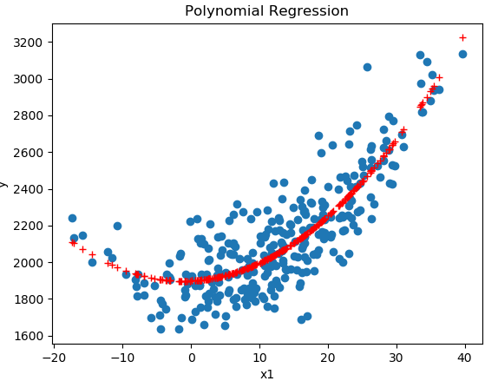
Residual analysis of polynomial regression
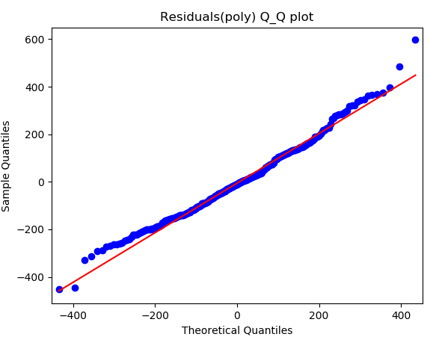
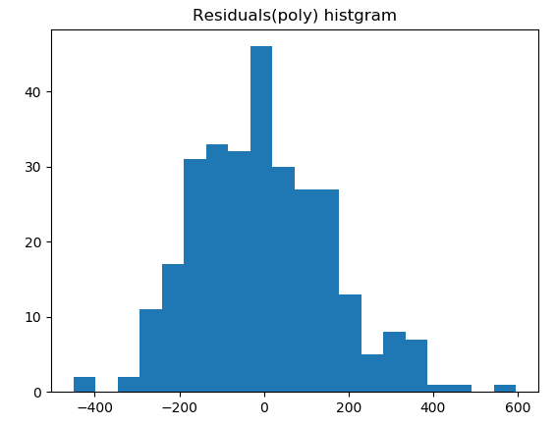


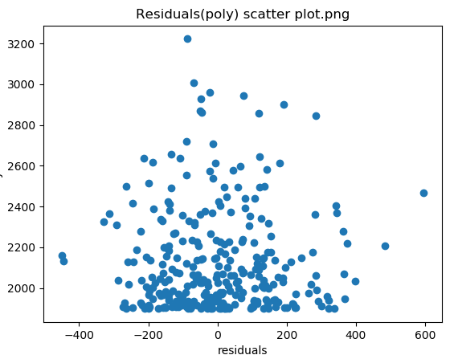
Comment
The results of polynomial regression show that the model has better fit comparing to simple linear regression. The R-squared, Q-Q plot have better scores than simple linear regression, and there is no discernible trend in the residuals scatter plot as well. However, the a₁ coefficients are not significant in this model and the residuals still not normal distributed even though the overall result is improved.
Task 3
Summary of multivariable regression
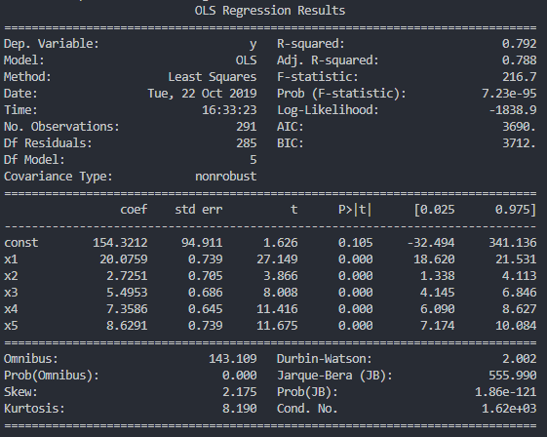
Residual analysis of multivariable regression
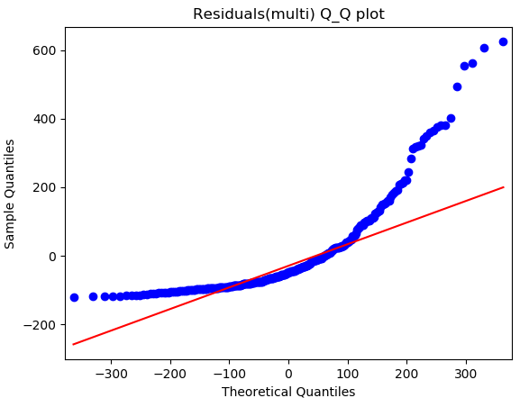
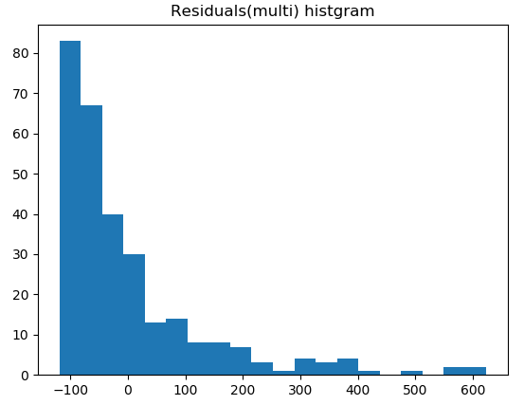

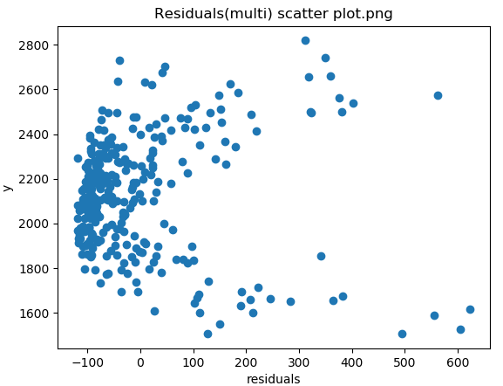

Comment
If we simply used all the independent variables, the residuals will strongly non-normal distributed. We can improve it by choose the observed strong correlation between Y and variables. In our case, we can simply only used x₁, which has the highest correlation with Y and the remaining variables are all under 0.5, then the result will be same as simple linear regression. However, in order to make them slightly different, we choose the first and second high correlation, which is x₁ and x₅, and re-do the multivariable regression.

Summary of improved multivariable regression
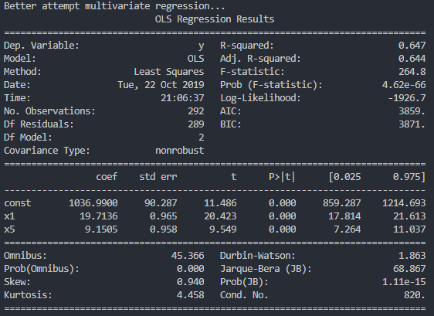

Residual analysis of multivariable regression
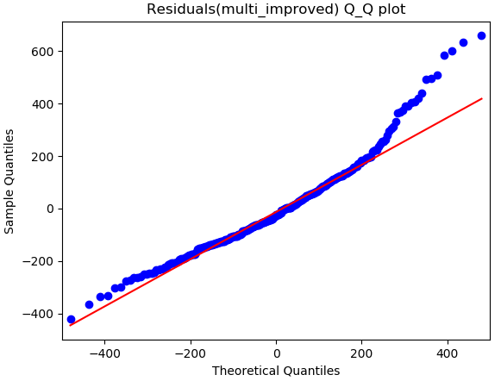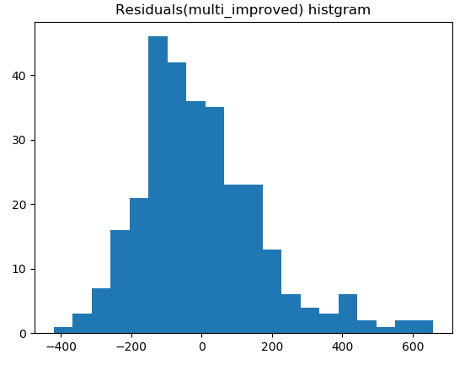
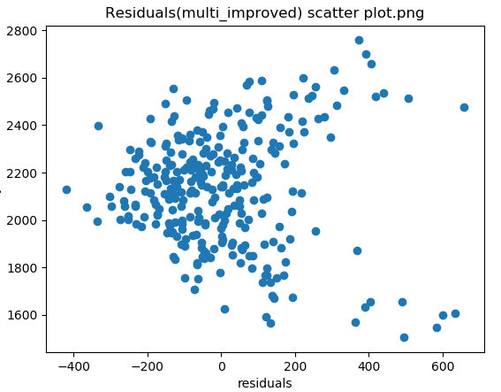
Comment
The residual results are improved after the better feature selection; however, we lost some data presentation to our model.

